Task on IAM
1.Create one IAM user and assign EC2 and S3 full access roles.
Go to IAM Service
STEP:1 Go to IAM Service
- Login to AWS Management Console.
- In the search bar, type AWS Identity and Access Management (IAM).
- Click IAM.
STEP:2 Create a New IAM User
- In the left panel click Users.
- Click Create user.
- Enter the User name (example: dev-user).
- Select access type:
- ✅ Provide user access to the AWS Management Console (if you want console login)
- Or create programmatic access for CLI/API.
- Click Next.
STEP:3 Set Permissions
- You must attach policies that give full access to EC2 and S3.
- Select Attach policies directly.
- Search and select these policies:
- AmazonEC2FullAccess
- AmazonS3FullAccess
- Click Next.

STEP:4 Review and Create
- Review the configuration.
- Click Create user.

STEP:5 Save Login Details
- AWS will show:
- Console login URL
- Username
- Password
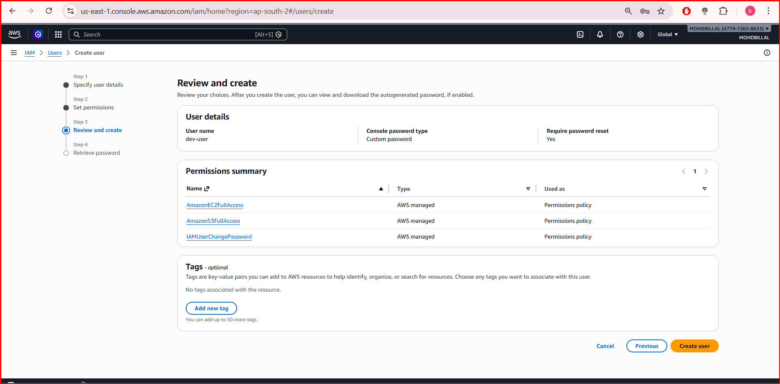
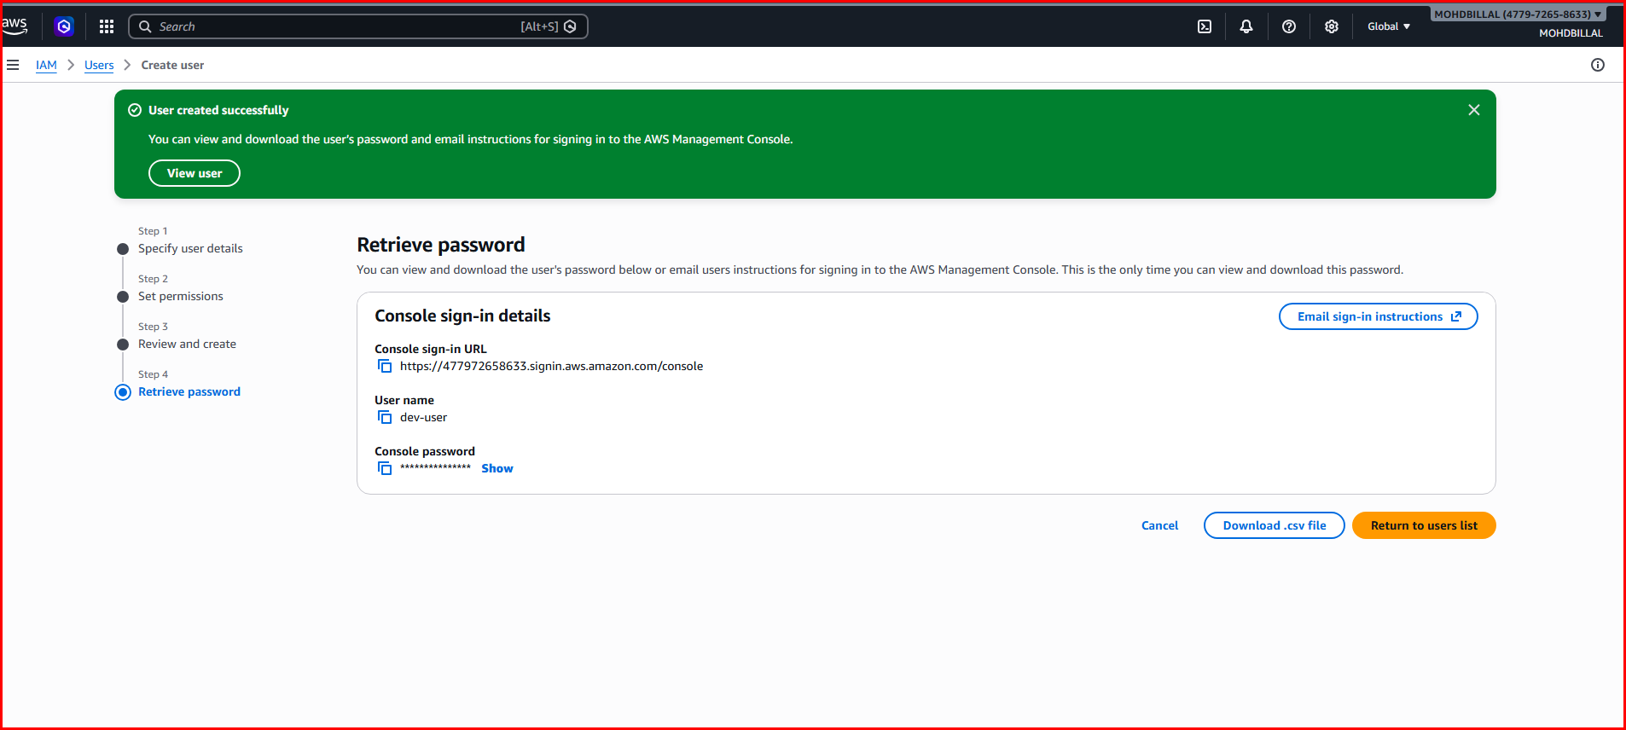
2. Create one group in IAM and assign read access for EC2.

STEP:1 Go to IAM Service
- Login to the AWS Management Console.
- Search for IAM in the services search bar.
- Open IAM Dashboard.

STEP:2 Create a New IAM Group
- In the left menu click User groups.
- Click Create group.
- Enter the Group name
Example: EC2-ReadOnly-Group

STEP:3 Attach Read-Only Policy for EC2
- In Attach permissions policies, search for:
- AmazonEC2ReadOnlyAccess
- Select the checkbox.
- Click Create group.

STEP:4 (Optional) Add Users to the Group
After creating the group:
- Open the EC2-ReadOnly-Group.
- Click Add users.
- Select the IAM user you created earlier.
- Click Add users.

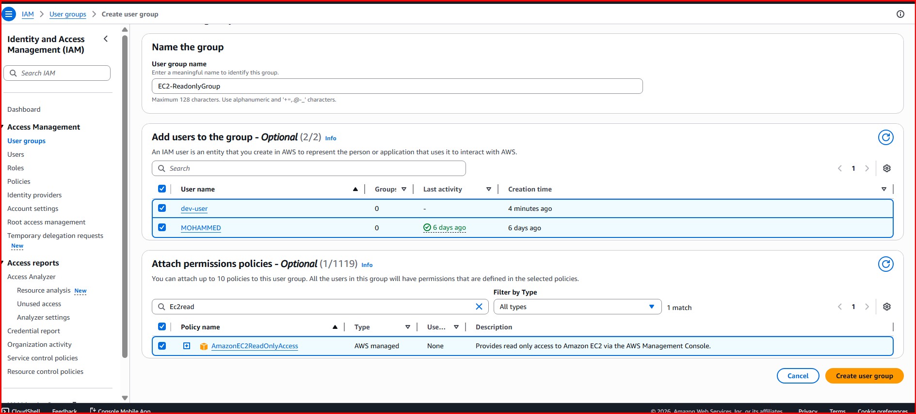
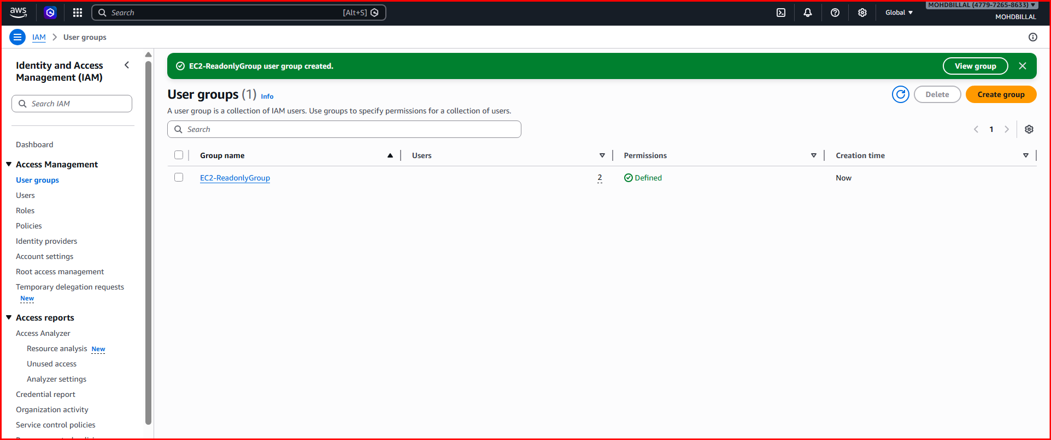
- Create a new user named "Devops" and add to the group created in task 2.

1. Open IAM
- Login to AWS Management Console.
- Search for IAM in the services search bar.
- Open IAM Dashboard.

2.Create the User
- Click Users in the left panel.
- Click Create user.
- Enter the User name:
Devops
- Select the access type (optional):
- ✅ Provide user access to the AWS Management Console (for web login)
- Click Next.

3. Add User to the Existing Group
- Choose Add user to group.
- Select the group created in Task 2:
- EC2-ReadOnly-Group
(This group already has AmazonEC2ReadOnlyAccess policy.)
- Click Next.

4 .Review and Create
- Review the settings.
- Click Create user.

5. Save Login Credentials
After creation, AWS will show:
- Console login URL
- Username: Devops
- Password

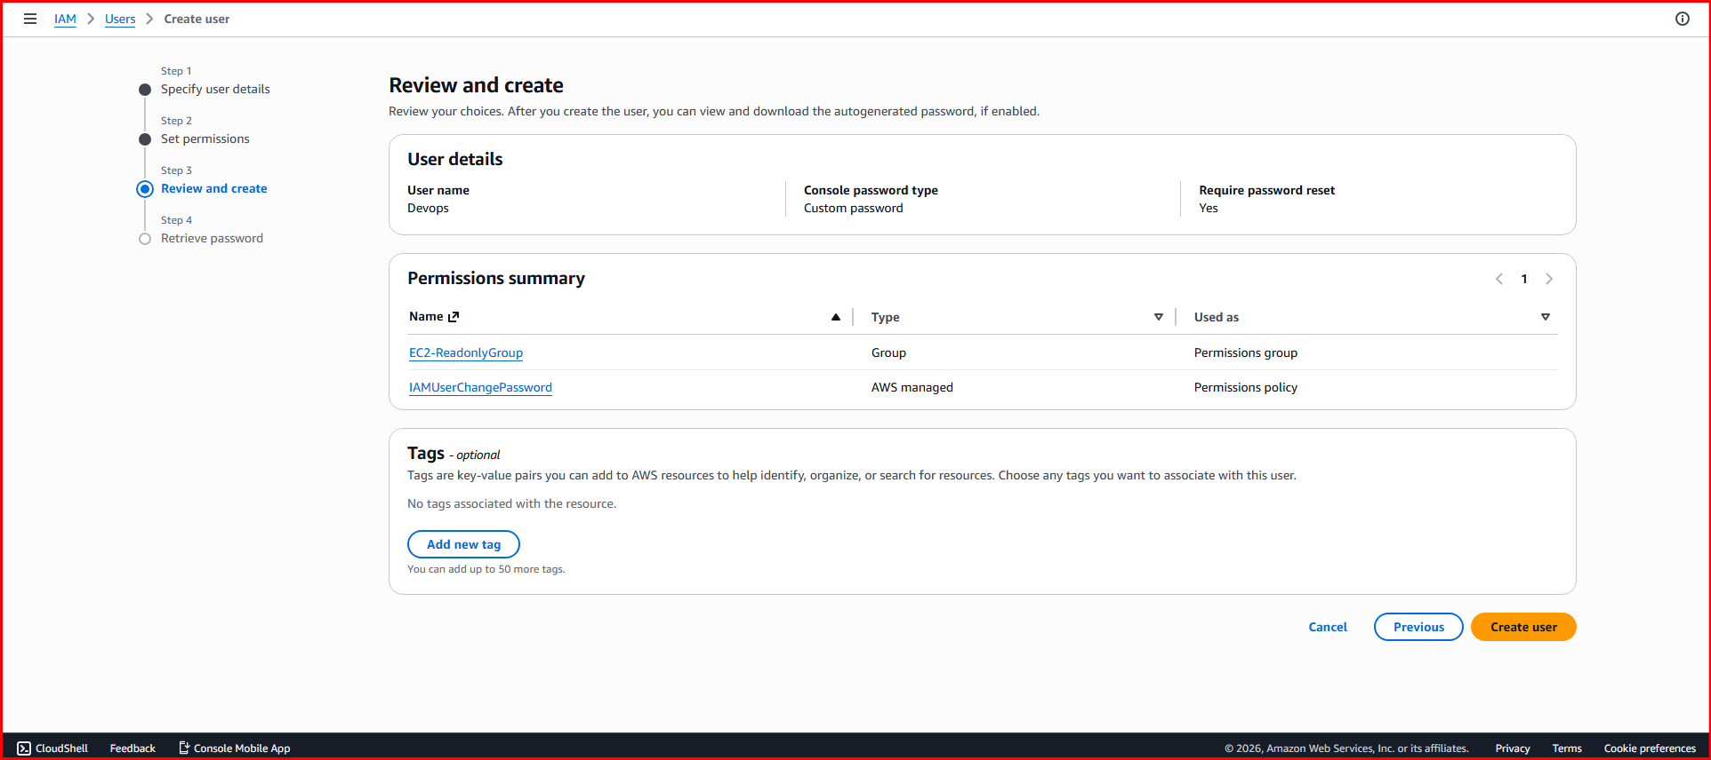
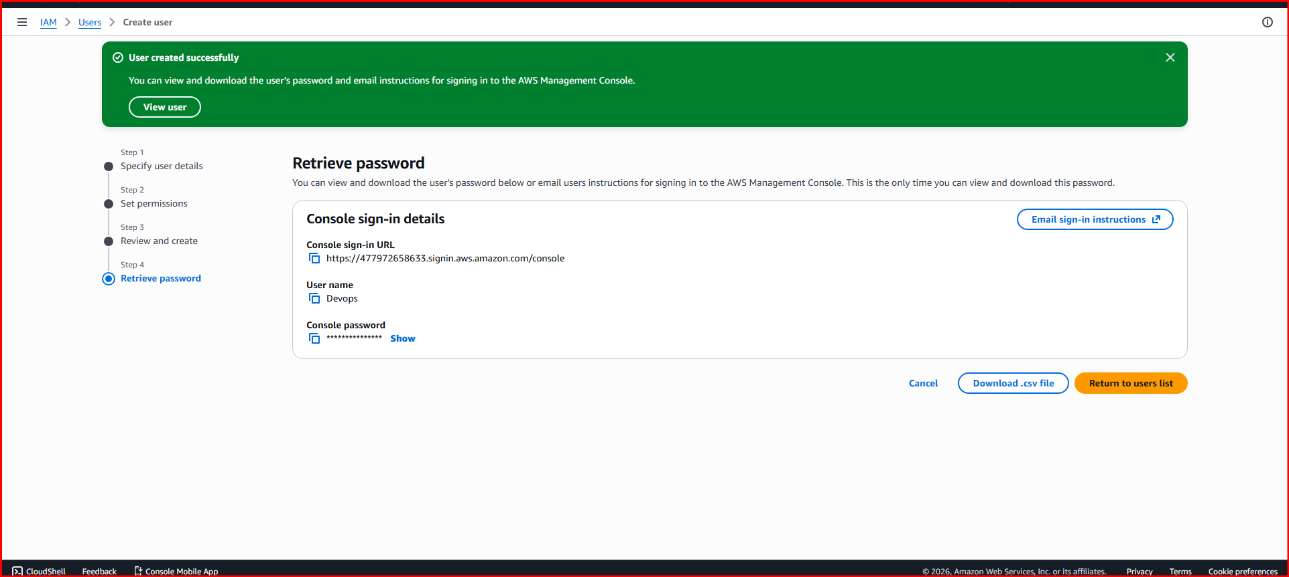
- Write a bash script to create an IAM user with VPC full access.
- Save the file
- nano create_user.sh
#!/bin/bash

# Username
USER_NAME="vpc-user"

echo "Creating IAM user..."

# Create IAM user
aws iam create-user --user-name $USER_NAME

echo "Attaching VPC Full Access policy..."

# Attach VPC Full Access policy
aws iam attach-user-policy \
--user-name $USER_NAME \
--policy-arn arn:aws:iam::aws:policy/AmazonVPCFullAccess

echo "IAM user $USER_NAME created with VPC Full Access."

Steps to Run the Script
1.Save the file
nano create_user.sh
Paste the script and save.

2.Give execute permission
chmod +x create_user.sh

3.Run the script
./create_user.sh

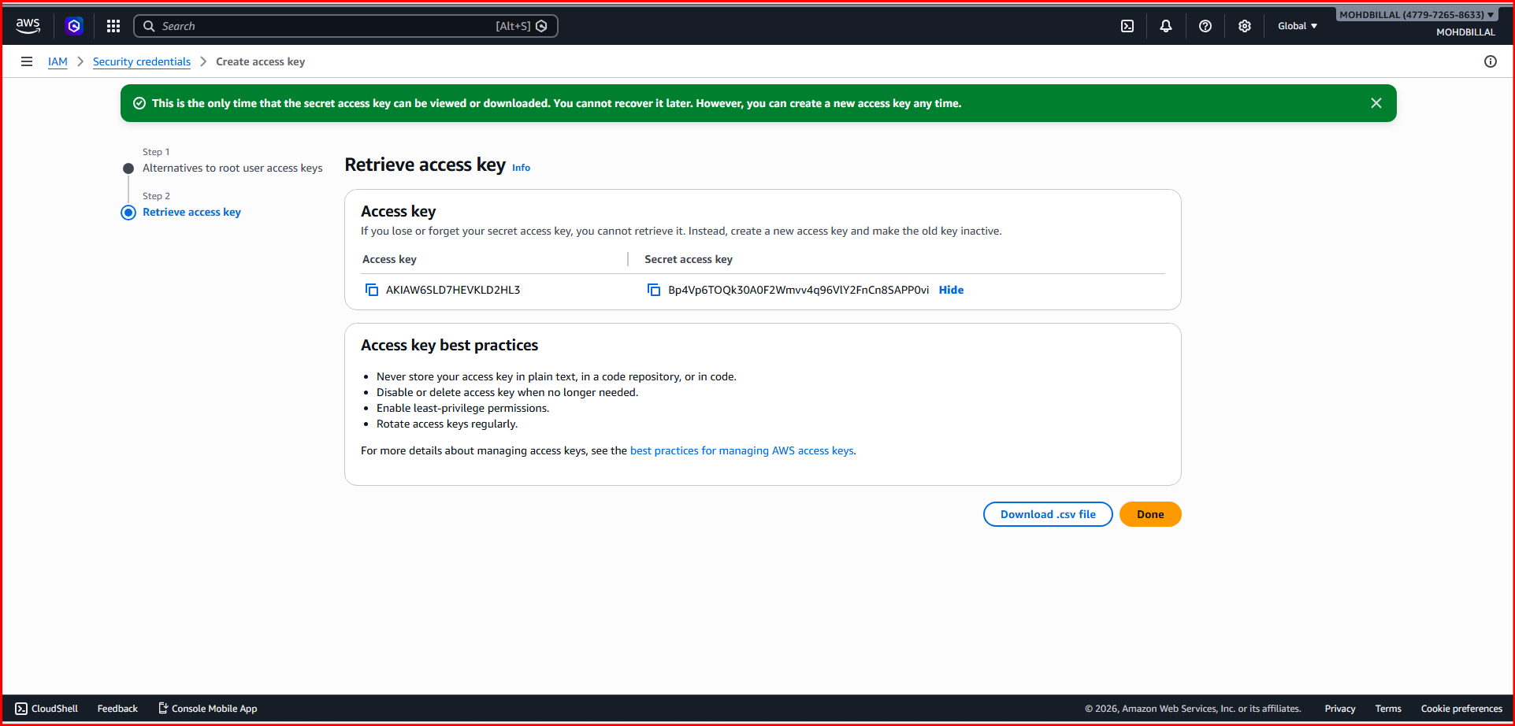
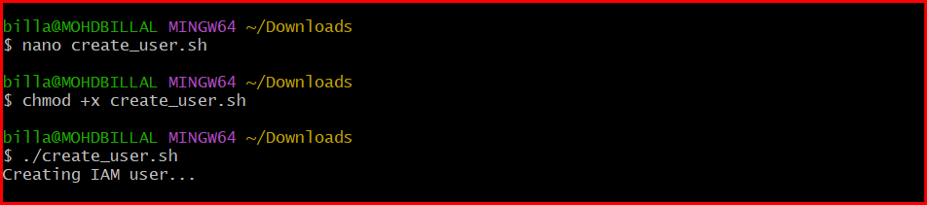
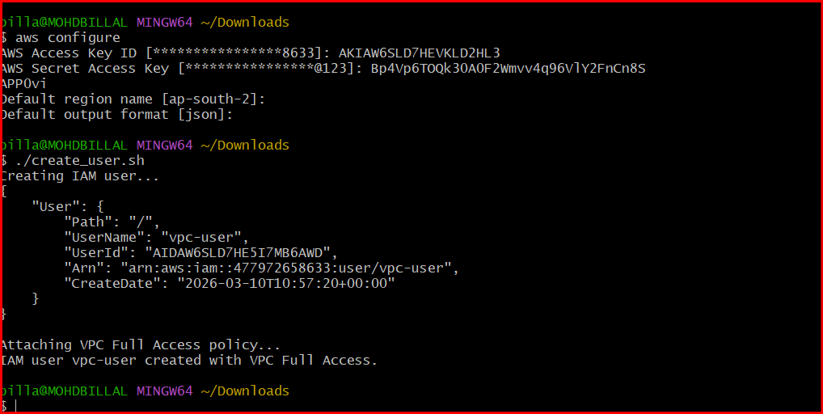
- Create an IAM policy to allow EC2 access for a specific user in specific regions only.

1.Example Scenario
User: Devops
Allowed Region: ap-south-1 (Mumbai)
Service: EC2
The user cannot use EC2 in other regions.

2. IAM Policy JSON
Create a new policy and paste this JSON:
{
"Version": "2012-10-17",
"Statement": [
{
"Sid": "EC2AccessSpecificRegion",
"Effect": "Allow",
"Action": "ec2:*",
"Resource": "*",
"Condition": {
"StringEquals": {
"aws:RequestedRegion": "ap-south-1"
}
}
}
]
}

3.Steps to Create the Policy
- Go to IAM console
- Click Policies
- Click Create Policy
- Choose JSON tab
- Paste the policy
- Click Next
- Name the policy
Example name:
EC2-Specific-Region-Access
- Click Create policy

4.Attach the Policy to the User
- Go to Users
- Select the user (example: Devops)
- Click Add permissions
- Choose Attach policies directly
- Select the new policy
- Save
